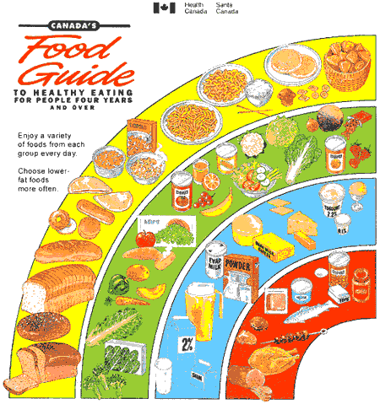
Canada Food Guide Poster Assignment
Name: ______________
Due Date: ____________
TOTAL: /40 marks

Objective: Create a small poster (ledger size) of the Canada Food Guide that includes the following: ·
- Title (Canada Food Guide)
- At least five pictures of food items for each of the four Food Groups for a total of 20 pictures (may be hand drawn, cut-out of magazines, internet pictures )
- Heading for each Food Group (ex. Grain products)
- The recommended number of servings per day for each food group (group must either reflect needs of Children 9-13 or Teens 14 – 18)
- Must be creatively presented (unique) and not replicate the current images used/ color schemes used by Health Canada
RUBRIC: You will be marked on the following criteria:
- Title.................................................................................... / 4
- Five Pictures for each Food Group.............................. / 20
- Heading for each Food Group....................................... / 4
- Recommended number of servings.............................. / 6
- Overall Layout / Neatness / Creativity...................... / 6

Total: /40

IMPORTANT: Please attach this handout to the back of the poster!

